## Chapter 5 Implementation Details

# Implementation

The system consists on five major modules i.e. Marker Hardware, Audio Hardware, Controller Application, Player Application and LMS Web Application. Implementation detail of each module is discussed below.

# Marker Hardware

The role of this module is to give orientation and tip pressure of the marker. The module sends data packet that contain encoded orientation of marker in 3d space in form of Euler angles.

## Requirements Addressed

|  |  |  |
| --- | --- | --- |
| **#** | **Requirement** | **Priority** |
|  |  |  |
| **1** | Determine orientation of board marker and calculate respective Euler angles | HIGH |
| **2** | Transmit the calculated Euler angles to desktop app via nrf24l01 module | HIGH |
| **3** | Transmit the calculated Euler angles to desktop app via RS232 serial connection | LOW |
| **4** | Turn on using 3.6 volts Li-po battery with Boost converter circuit | MEDIUM |
| **5** | Build battery charging circuit within board marker | LOW |
| **6** | Implement RGB Led for positioning purpose (Input for camera module) | HIGH |

Table 5.1: Board Marker Hardware Requirements

## General Flow

* Board Marker try to establish wireless connection with the receiver. RGB Led fades meanwhile.
* RGB Led turns to constant red after successful connection.
* Accelerometer unit in the Board Marker determines the orientation data.
* NRF24l01 wireless module in the Board Marker transmits the orientation data to Receiver wirelessly.
* Receiver Transfers orientation data to desktop app via serial connection

## Detailed Design

Marker hardware has two major sub-modules named as **Transmitter** (marker itself)and **Receiver**

|  |  |  |
| --- | --- | --- |
| **Component Number** | **Description** | **Diagram** |
|  |  |  |
| **1** | **Name:** Tact Tactile Switch | Figure 5.1 - Tact Tactile Switch |
| **Detail:** Toggle switch that turns on/off the system when runs on Battery. It does not have any effect when system is running via USB cable. |
| **2** | **Name:** USB DC-DC Boost Converter | Figure 5.2 - DC-DC Boost Converter |
| **Detail:** Converts the 3.7V to 5V to turn on and constantly run the Arduino nano prototype board. This sub-module has built-in charging circuit that charges the battery through USB connection. |
| **3** | **Name:** Glowing ball | Figure 5.3 - Glowing Ball |
| **Detail:** Round shaped glowing ball can glow in any combination of RGB colors. It is not for just looks but acts as an input to Stereo cameras for position tracking. |
| **4** | **Name:** Arduino nano | Figure 5.4 - Arduino nano |
| **Detail:** Arduino nano acts as main processing board to which all modules and sensors are attached. It acts just like a motherboard with central processor chip soldered on mainboard. |
| **5** | **Name:** Li-po battery | Figure 5.5 – Li-po Battery |
| **Detail:** 600mAh 3.7V Lipo battery used to run system while there is no USB connection. Voltage may be up to 4.2 volts when fully charged.  DC-DC Boost Converter is hooked up with the battery that charges the battery as well as raises its voltage to 5V to make the Board Marker Transmitter working properly. |
| **6** | **Name:** dc-le14112 RGB Led | Figure 5.6 - RGB Led |
| **Detail:** 3W RGB Led used to create custom color of choice, the corresponding color that is required for position sensing can glow in Glowing ball. It may be given external power source but, in our case, it is directly connected to Arduino nano. |
| **7** | **Name:** MPU-6050 | Figure 5.7 - MPU-6050 |
| **Detail:** MPU-6050 or GY-521 board contains accelerometer and gyroscope packed in a single chip. It senses the orientation of the object. It is connected to Arduino nano via I2C bus. |
| **8** | **Name:** nRF24L01 | Figure 5.8 - nRF24L01 |
| **Detail:** nRF24L01 is a single chip radio transceiver. It is responsible for transmitting orientation data from transmitter module to receiver. |

Table 5.2: Board Marker Components Detail

## Marker Transmitter

The objective of the transmitter module is to extract orientation of the board marker. The challenge is the marker is changing its orientation while writing on the board. Transmitter module is designed as a back cap of board marker. It is attached to the board marker to record orientation of marker. The role of this sub-module is to transmit the tip pressure and orientation of marker in space. Further details of each part constituting the transmitter are given below.

### Components Used

Detailed description of electronic components excluding discrete consumer parts, e.g. wires, is given below and described in Table 5.2.

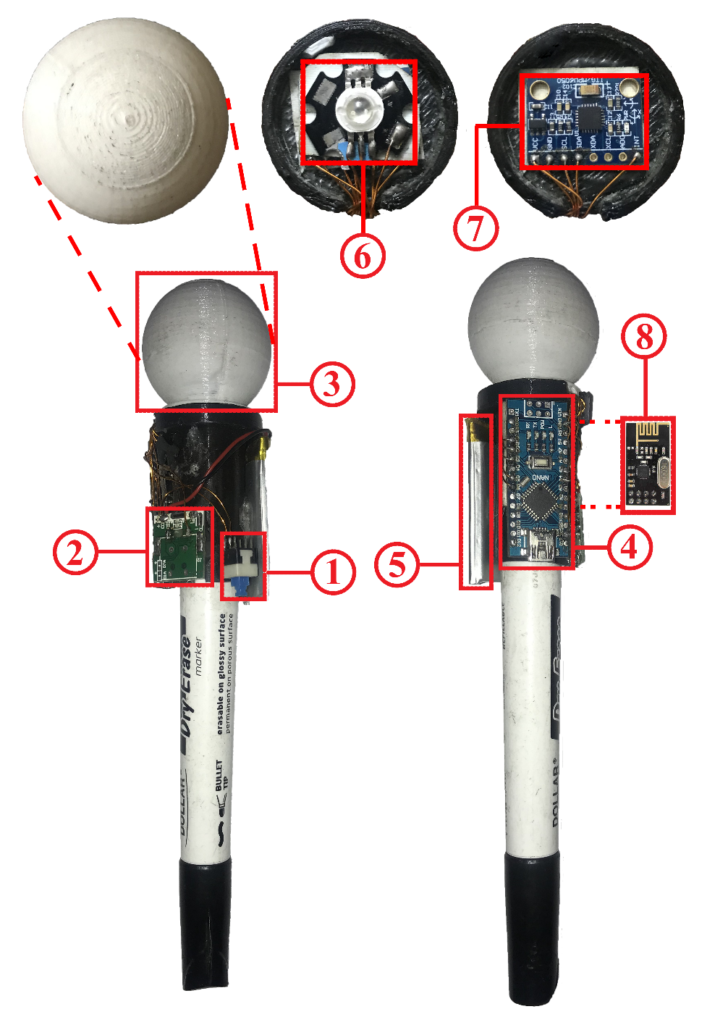

Figure 5.9: Board Marker Transmitter Component Detail

### Component Connection Diagram

This diagram represents how sub-modules or components are connected in Transmitter module.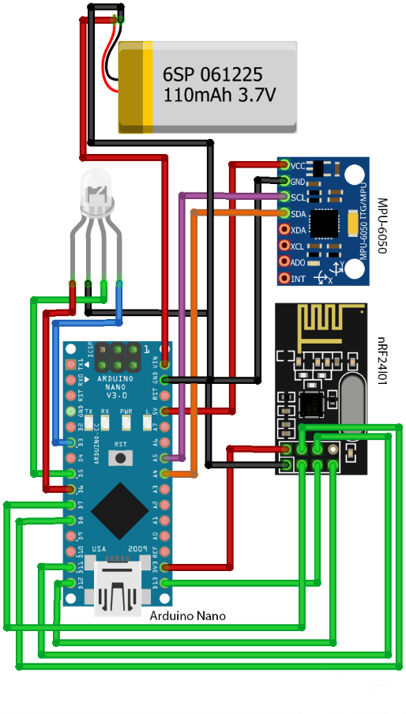

Figure 5.10: Component connection diagram of Board Marker Transmitter

### Schematic Diagram

Schematic diagram of Board Marker Transmitter can be seen as below

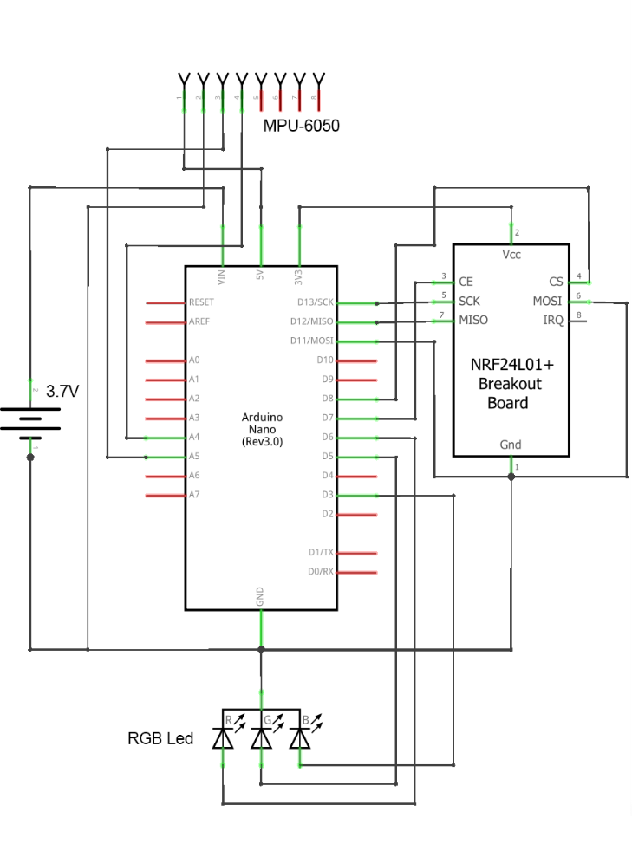

Figure 5.11: Schematic diagram of Board Marker Transmitter

### General Flow

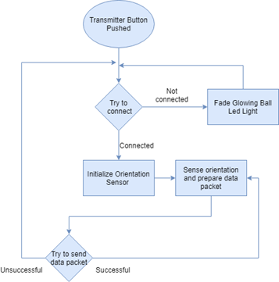

Figure 5.12: General Flow of Board Marker Transmitter

## Marker Receiver

Receiver module receives orientation data as Euler angles and transfer it to the desktop application via USB connection. As it is connected via USB so it does not need any external power source.

### Component Connection Diagram

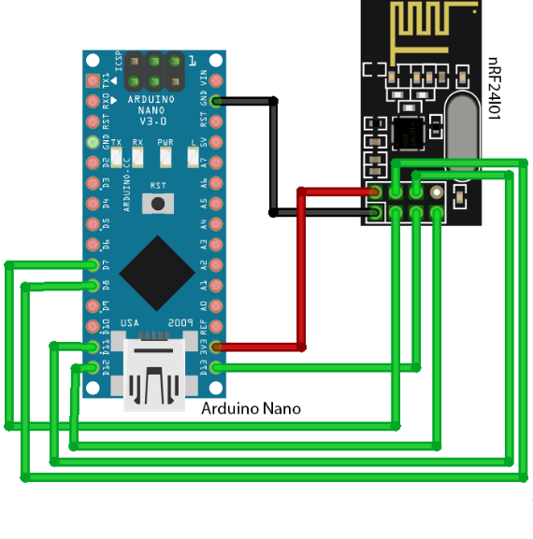

Figure 5.13: Component connection diagram of Board Marker Receiver

### Schematic Diagram

Schematic diagram that shows abstract component view of Receiver module is given below

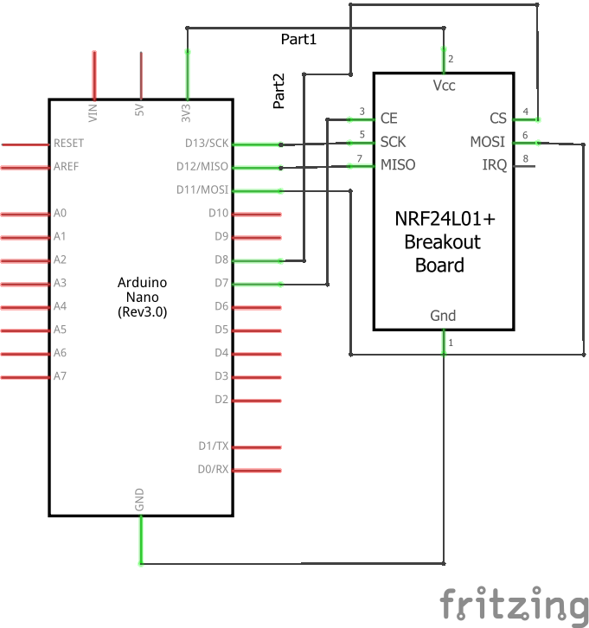

Figure 5.14: Schematic diagram of Board Marker Receiver

### General Flow

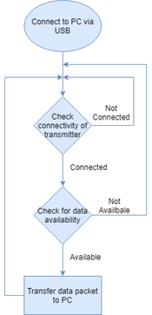

Figure 5.15: General Flow of Board Marker Receiver

## Rules and Assumptions

Following are rules and cases of assumptions that are assumed to be true while normal working

* Board Marker Transmitter and Receiver are in range of 2 meters for less noise and preventing latency issues.
* Pressure threshold of board marker tip is 5Pascals that is equivalent to pressure of lead pencil tip. Above this pressure, marker will write and otherwise not.
* Glowing ball of board marker must be at least partially visible by either of the cameras. Precision of marker position decreases from Case 1 to 6. Best Accuracy in Case 1 and no output at all in Case 6.
* User is supposed to be not touching the Marker tip while recording the lecture.
* User is supposed to be write only in the boundary of the defined platform i.e. whiteboard.

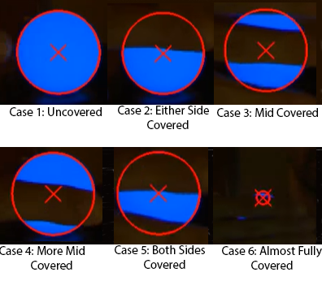

Figure 5.16: Glowing Ball Detection While Covered

## Tools and Technologies used

List all software that are used to develop and needed to operate the developed module are detailed below.

### Arduino IDE v1.8.9

Code environment in which all code for Board Maker Transmitter and Receiver is written. This IDE is numerously used as a debugging tool as well.

### Processing v3.5.3

This tool is used for debugging and visualization of Board Marker Transmitter as a teapot object. In order to view Board Marker Transmitter and verify the placement of MPU-6050 orientation sensor and latency, we visualized the teapot object moving in the window of Processing software. Following parameters and properties are visualized and debugged.

* Correct orientation data packet format of Board Marker Transmitter.
* Generation of noise with respect to obstacles and distance involved while data transmission.
* Latency in data transmission with respect to obstacles and distance involved while data transmission.

Sample image of object is given below

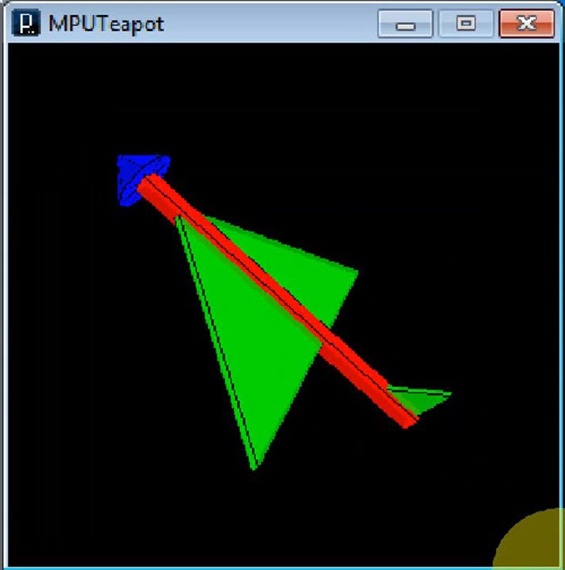

Figure 5.17: Marker Orientation Image in Processing Software